What is a Process?
A program in the execution is called a Process. Process is not the same as program. A process is more than a program code. A process is an 'active' entity as opposed to program which is considered to be a 'passive' entity. Attributes held by process include hardware state, memory, CPU etc.
Process memory is divided into four sections for efficient working :
- The text section is made up of the compiled program code, read in from non-volatile storage when the program is launched.
- The data section is made up the global and static variables, allocated and initialized prior to executing the main.
- The heap is used for the dynamic memory allocation, and is managed via calls to new, delete, malloc, free, etc.
- The stack is used for local variables. Space on the stack is reserved for local variables when they are declared.

PROCESS STATE
Processes can be any of the following states :
- New - The process is in the stage of being created.
- Ready - The process has all the resources available that it needs to run, but the CPU is not currently working on this process's instructions.
- Running - The CPU is working on this process's instructions.
- Waiting - The process cannot run at the moment, because it is waiting for some resource to become available or for some event to occur.
- Terminated - The process has completed.
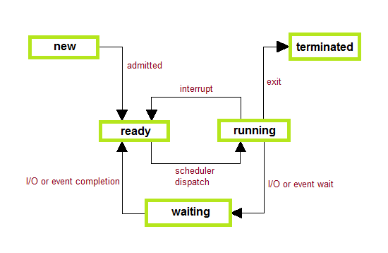

PROCESS CONTROL BLOCK
There is a Process Control Block for each process, enclosing all the information about the process. It is a data structure, which contains the following :
- Process State - It can be running, waiting etc.
- Process ID and parent process ID.
- CPU registers and Program Counter. Program Counter holds the address of the next instruction to be executed for that process.
- CPU Scheduling information - Such as priority information and pointers to scheduling queues.
- Memory Management information - Eg. page tables or segment tables.
- Accounting information - user and kernel CPU time consumed, account numbers, limits, etc.
- I/O Status information - Devices allocated, open file tables, etc.
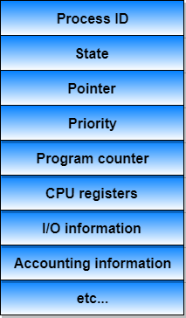

Process Scheduling
The act of determining which process in the ready state should be moved to the running state is known as Process Scheduling.
The prime aim of the process scheduling system is to keep the CPU busy all the time and to deliver minimum response time for all programs. For achieving this, the scheduler must apply appropriate rules for swapping processes IN and OUT of CPU.
Schedulers fell into one of the two general categories :
- Non pre-emptive scheduling. When the currently executing process gives up the CPU voluntarily.
- Pre-emptive scheduling. When the operating system decides to favour another process, pre-empting the currently executing process.

Scheduling Queues
- All processes when enters into the system are stored in the job queue.
- Processes in the Ready state are placed in the ready queue.
- Processes waiting for a device to become available are placed in device queues. There are unique device queues for each I/O device available.

Types of Schedulers
There are three types of schedulers available :
- Long Term Scheduler :
Long term scheduler runs less frequently. Long Term Schedulers decide which program must get into the job queue. From the job queue, the Job Processor, selects processes and loads them into the memory for execution. Primary aim of the Job Scheduler is to maintain a good degree of Multiprogramming. An optimal degree of Multiprogramming means the average rate of process creation is equal to the average departure rate of processes from the execution memory.
- Short Term Scheduler :
This is also known as CPU Scheduler and runs very frequently. The primary aim of this scheduler is to enhance CPU performance and increase process execution rate.
- Medium Term Scheduler :
During extra load, this scheduler picks out big processes from the ready queue for some time, to allow smaller processes to execute, thereby reducing the number of processes in the ready queue.

Operations on Process

Process Creation
Through appropriate system calls, such as fork or spawn, processes may create other processes. The process which creates other process, is termed the parent of the other process, while the created sub-process is termed its child.
Each process is given an integer identifier, termed as process identifier, or PID. The parent PID (PPID) is also stored for each process.
On a typical UNIX systems the process scheduler is termed as sched, and is given PID 0. The first thing done by it at system start-up time is to launch init, which gives that process PID 1. Further Init launches all the system daemons and user logins, and becomes the ultimate parent of all other processes.
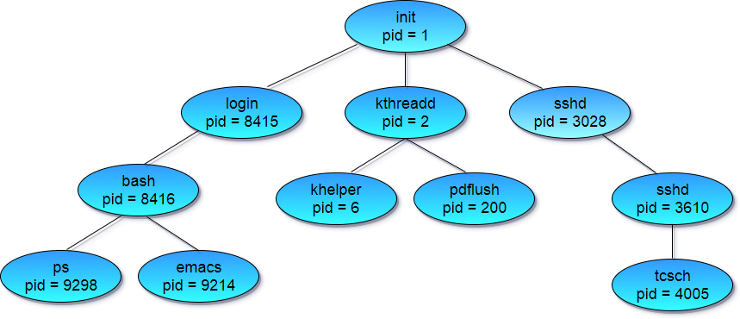
A child process may receive some amount of shared resources with its parent depending on system implementation. To prevent runaway children from consuming all of a certain system resource, child processes may or may not be limited to a subset of the resources originally allocated to the parent.
There are two options for the parent process after creating the child :
- Wait for the child process to terminate before proceeding. Parent process makes a wait() system call, for either a specific child process or for any particular child process, which causes the parent process to block until the wait() returns. UNIX shells normally wait for their children to complete before issuing a new prompt.
- Run concurrently with the child, continuing to process without waiting. When a UNIX shell runs a process as a background task, this is the operation seen. It is also possible for the parent to run for a while, and then wait for the child later, which might occur in a sort of a parallel processing operation.

Process Termination
By making the exit(system call), typically returning an int, processes may request their own termination. This int is passed along to the parent if it is doing a wait(), and is typically zero on successful completion and some non-zero code in the event of any problem.
Processes may also be terminated by the system for a variety of reasons, including :
- The inability of the system to deliver the necessary system resources.
- In response to a KILL command or other unhandled process interrupts.
- A parent may kill its children if the task assigned to them is no longer needed i.e. if the need of having a child terminates.
- If the parent exits, the system may or may not allow the child to continue without a parent (In UNIX systems, orphaned processes are generally inherited by init, which then proceeds to kill them.)
When a process ends, all of its system resources are freed up, open files flushed and closed, etc. The process termination status and execution times are returned to the parent if the parent is waiting for the child to terminate, or eventually returned to init if the process already became an orphan.
The processes which are trying to terminate but cannot do so because their parent is not waiting for them are termed zombies. These are eventually inherited by init as orphans and killed off.

CPU Scheduling
CPU scheduling is a process which allows one process to use the CPU while the execution of another process is on hold(in waiting state) due to unavailability of any resource like I/O etc, thereby making full use of CPU. The aim of CPU scheduling is to make the system efficient, fast and fair.

Scheduling Criteria
There are many different criterias to check when considering the "best" scheduling algorithm :
- CPU utilization
To make out the best use of CPU and not to waste any CPU cycle, CPU would be working most of the time(Ideally 100% of the time). Considering a real system, CPU usage should range from 40% (lightly loaded) to 90% (heavily loaded.)
- Throughput
It is the total number of processes completed per unit time or rather say total amount of work done in a unit of time. This may range from 10/second to 1/hour depending on the specific processes.
- Turnaround time
It is the amount of time taken to execute a particular process, i.e. The interval from time of submission of the process to the time of completion of the process(Wall clock time).
- Waiting time
The sum of the periods spent waiting in the ready queue amount of time a process has been waiting in the ready queue to acquire get control on the CPU.
- Load average
It is the average number of processes residing in the ready queue waiting for their turn to get into the CPU.
- Response time
Amount of time it takes from when a request was submitted until the first response is produced. Remember, it is the time till the first response and not the completion of process execution(final response).
In general CPU utilization and Throughput are maximized and other factors are reduced for proper optimization.

Scheduling Algorithms
We'll discuss four major scheduling algorithms here which are following :
- First Come First Serve(FCFS) Scheduling
- Shortest-Job-First(SJF) Scheduling
- Priority Scheduling
- Round Robin(RR) Scheduling
- Multilevel Queue Scheduling

First Come First Serve(FCFS) Scheduling
- Jobs are executed on first come, first serve basis.
- Easy to understand and implement.
- Poor in performance as average wait time is high.
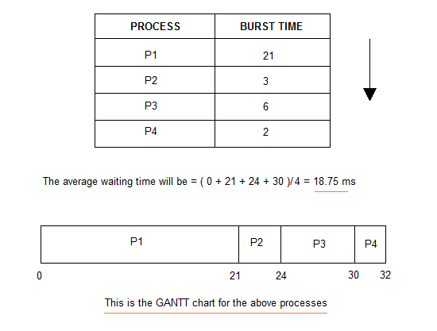

Shortest-Job-First(SJF) Scheduling
- Best approach to minimize waiting time.
- Actual time taken by the process is already known to processor.
- Impossible to implement.
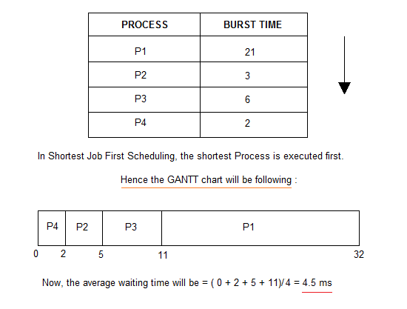

In Preemptive Shortest Job First Scheduling, jobs are put into ready queue as they arrive, but as a process with short burst time arrives, the existing process is preemptied.
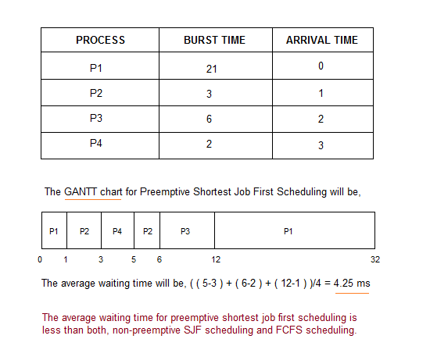

Priority Scheduling
- Priority is assigned for each process.
- Process with highest priority is executed first and so on.
- Processes with same priority are executed in FCFS manner.
- Priority can be decided based on memory requirements, time requirements or any other resource requirement.
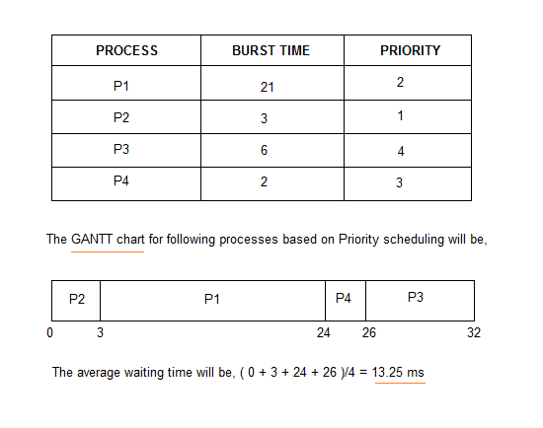

Round Robin(RR) Scheduling
- A fixed time is allotted to each process, called quantum, for execution.
- Once a process is executed for given time period that process is preemptied and other process executes for given time period.
- Context switching is used to save states of preemptied processes.
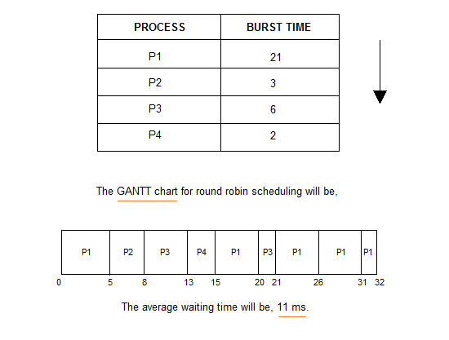

Multilevel Queue Scheduling
- Multiple queues are maintained for processes.
- Each queue can have its own scheduling algorithms.
- Priorities are assigned to each queue.

What are Threads?
Thread is an execution unit which consists of its own program counter, a stack, and a set of registers. Threads are also known as Lightweight processes. Threads are popular way to improve application through parallelism. The CPU switches rapidly back and forth among the threads giving illusion that the threads are running in parallel.
As each thread has its own independent resource for process execution, multpile processes can be executed parallely by increasing number of threads.
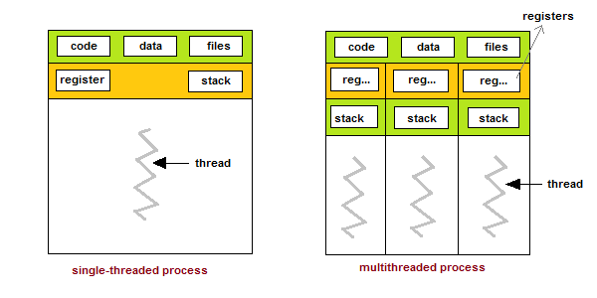

Types of Thread
There are two types of threads :
- User Threads
- Kernel Threads
User threads, are above the kernel and without kernel support. These are the threads that application programmers use in their programs.
Kernel threads are supported within the kernel of the OS itself. All modern OSs support kernel level threads, allowing the kernel to perform multiple simultaneous tasks and/or to service multiple kernel system calls simultaneously.

Multithreading Models
The user threads must be mapped to kernel threads, by one of the following strategies.
- Many-To-One Model
- One-To-One Model
- Many-To-Many Model

Many-To-One Model
- In the many-to-one model, many user-level threads are all mapped onto a single kernel thread.
- Thread management is handled by the thread library in user space, which is efficient in nature.
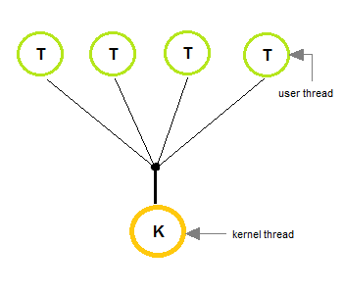

One-To-One Model
- The one-to-one model creates a separate kernel thread to handle each and every user thread.
- Most implementations of this model place a limit on how many threads can be created.
- Linux and Windows from 95 to XP implement the one-to-one model for threads.
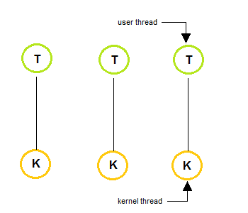

Many-To-Many Model
- The many-to-many model multiplexes any number of user threads onto an equal or smaller number of kernel threads, combining the best features of the one-to-one and many-to-one models.
- Users can create any number of the threads.
- Blocking the kernel system calls does not block the entire process.
- Processes can be split across multiple processors.
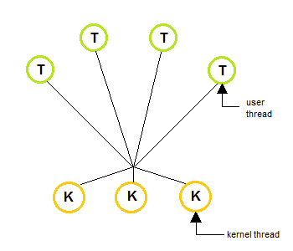

Thread Libraries
Thread libraries provides programmers with API for creating and managing of threads.
Thread libraries may be implemented either in user space or in kernel space. The user space involves API functions implemented solely within user space, with no kernel support. The kernel space involves system calls, and requires a kernel with thread library support.

There are three types of thread :
- POSIX Pitheads, may be provided as either a user or kernel library, as an extension to the POSIX standard.
- Win32 threads, are provided as a kernel-level library on Windows systems.
- Java threads - Since Java generally runs on a Java Virtual Machine, the implementation of threads is based upon whatever OS and hardware the JVM is running on, i.e. either Pitheads or Win32 threads depending on the system

Benefits of Multithreading
- Responsiveness
- Resource sharing, hence allowing better utilization of resources.
- Economy. Creating and managing threads becomes easier.
- Scalability. One thread runs on one CPU. In Multithreaded processes, threads can be distributed over a series of processors to scale.
- Context Switching is smooth. Context switching refers to the procedure followed by CPU to change from one task to another.

Multithreading Issues
- Thread Cancellation.
Thread cancellation means terminating a thread before it has finished working. There can be two approaches for this, one is Asynchronous cancellation, which terminates the target thread immediately. The other is Deferred cancellation allows the target thread to periodically check if it should be cancelled.
- Signal Handling.
Signals are used in UNIX systems to notify a process that a particular event has occurred. Now in when a Multithreaded process receives a signal, to which thread it must be delivered? It can be delivered to all, or a single thread.
- fork() System Call.
fork() is a system call executed in the kernel through which a process creates a copy of itself. Now the problem in Multithreaded process is, if one thread forks, will the entire process be copied or not?
- Security Issues because of extensive sharing of resources between multiple threads.
There are many other issues that you might face in a multithreaded process, but there are appropriate solutions available for them. Pointing out some issues here was just to study both sides of the coin.

Process Synchronization
Process Synchronization means sharing system resources by processes in a such a way that, Concurrent access to shared data is handled thereby minimizing the chance of inconsistent data. Maintaining data consistency demands mechanisms to ensure synchronized execution of cooperating processes.
Process Synchronization was introduced to handle problems that arose while multiple process executions. Some of the problems are discussed below.

Critical Section Problem
A Critical Section is a code segment that accesses shared variables and has to be executed as an atomic action. It means that in a group of cooperating processes, at a given point of time, only one process must be executing its critical section. If any other process also wants to execute its critical section, it must wait until the first one finishes.
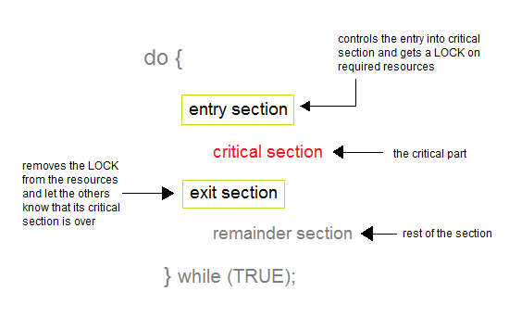

Solution to Critical Section Problem
A solution to the critical section problem must satisfy the following three conditions :
- Mutual Exclusion
Out of a group of cooperating processes, only one process can be in its critical section at a given point of time.
- Progress
If no process is in its critical section, and if one or more threads want to execute their critical section then any one of these threads must be allowed to get into its critical section.
- Bounded Waiting
After a process makes a request for getting into its critical section, there is a limit for how many other processes can get into their critical section, before this process's request is granted. So after the limit is reached, system must grant the process permission to get into its critical section.

Synchronization Hardware
Many systems provide hardware support for critical section code. The critical section problem could be solved easily in a single-processor environment if we could disallow interrupts to occur while a shared variable or resource is being modified.
In this manner, we could be sure that the current sequence of instructions would be allowed to execute in order without pre-emption. Unfortunately, this solution is not feasible in a multiprocessor environment.
Disabling interrupt on a multiprocessor environment can be time consuming as the message is passed to all the processors.
This message transmission lag, delays entry of threads into critical section and the system efficiency decreases.

Mutex Locks
As the synchronization hardware solution is not easy to implement for everyone, a strict software approach called Mutex Locks was introduced. In this approach, in the entry section of code, a LOCK is acquired over the critical resources modified and used inside critical section, and in the exit section that LOCK is released.
As the resource is locked while a process executes its critical section hence no other process can access it.

Semaphores
In 1965, Dijkstra proposed a new and very significant technique for managing concurrent processes by using the value of a simple integer variable to synchronize the progress of interacting processes. This integer variable is called semaphore. So it is basically a synchronizing tool and is accessed only through two low standard atomic operations, wait and signal designated by P() and V() respectively.
The classical definition of wait and signal are :
- Wait : decrement the value of its argument S as soon as it would become non-negative.
- Signal : increment the value of its argument, S as an individual operation.

Properties of Semaphores
- Simple
- Works with many processes
- Can have many different critical sections with different semaphores
- Each critical section has unique access semaphores
- Can permit multiple processes into the critical section at once, if desirable.

Types of Semaphores
Semaphores are mainly of two types:
- Binary Semaphore
It is a special form of semaphore used for implementing mutual exclusion, hence it is often called Mutex. A binary semaphore is initialized to 1 and only takes the value 0 and 1 during execution of a program.
- Counting Semaphores
These are used to implement bounded concurrency.

Limitations of Semaphores
- Priority Inversion is a big limitation of semaphores.
- Their use is not enforced, but is by convention only.
- With improper use, a process may block indefinitely. Such a situation is called Deadlock. We will be studying deadlocks in details in coming lessons.

Classical Problem of Synchronization
Following are some of the classical problem faced while process synchronaization in systems where cooperating processes are present.

Bounded Buffer Problem
- This problem is generalised in terms of the Producer-Consumer problem.
- Solution to this problem is, creating two counting semaphores "full" and "empty" to keep track of the current number of full and empty buffers respectively.

The Readers Writers Problem
- In this problem there are some processes(called readers) that only read the shared data, and never change it, and there are other processes(called writers) who may change the data in addition to reading or instead of reading it.
- There are various type of the readers-writers problem, most centred on relative priorities of readers and writers

Dining Philosophers Problem
- The dining philosopher's problem involves the allocation of limited resources from a group of processes in a deadlock-free and starvation-free manner.
- There are five philosophers sitting around a table, in which there are five chopsticks kept beside them and a bowl of rice in the centre, When a philosopher wants to eat, he uses two chopsticks - one from their left and one from their right. When a philosopher wants to think, he keeps down both chopsticks at their original place.

